|  |  |  |
| --- | --- | --- |
| S.NO. | NAME OF EXPERIMENT | TEACHER SIGNATURE |
| 1. | Installation of arduino |  |
| 2. | Write series LED blinking program in Arduino with help of push button. |  |
| 3. | Write a parallel LED blinking program by using slider switch. |  |
| 4. | Write a ON/OFF program of DC motor and also display motor current and resistance. |  |
| 5. | Write a program to run servo motor with help of resistor and slider switch. |  |
| 6. | Write a program of interface LDR sensor with Arduino. |  |
| 7. | Write a program of interface any sensor with Arduino |  |
| 8. | Write a program to interface LDR sensor and display data on LCD. |  |
| 9. | Write a program of Intruder sensing. |  |
| 10. | Write a program of Duty cycle through Oscilloscope. |  |
| 11. | : Write a program of controlling motor through NPN Resistor |  |
| 12. | Write a Program of Run motor forward/Reverse motion by using H-Bridge motor driver circuit. |  |
| 13. | Write a Program to sense data from ultrasonic sensor and run two geared motor. |  |
| 14. | Write a program of sense data from ultrasonic sensor and run servomotor. |  |
| 15. | Write a program to run any output device with help of relay module. |  |
| 16. | Write a program to sense data from PIR sensor and RUN any Electrical devices through relay module. |  |

**TABLE OF CONTENT**

# **E.NO 2: Write series LED blinking program in Arduino with help of push button.**

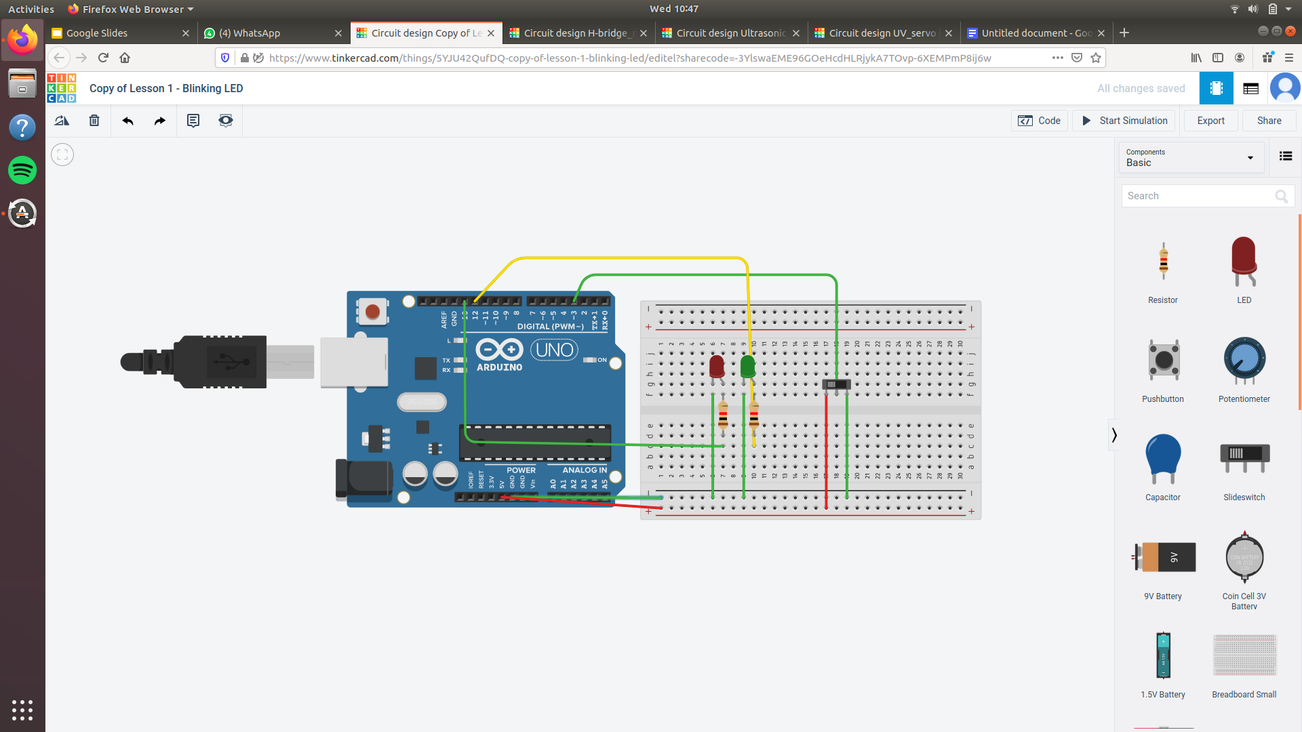

# **E.NO 2: Write series LED blinking program in Arduino with help of push button.**

const int switchPin = 3;

const int led1Pin = 12;

const int led2Pin = 13;

void setup()

{

pinMode(switchPin, INPUT);

pinMode(led1Pin, OUTPUT);

pinMode(led2Pin, OUTPUT);

}

void loop() {

int switchVal;

switchVal = digitalRead(switchPin);

if (switchVal == HIGH) {

digitalWrite(led1Pin, HIGH);

delay(500);

digitalWrite(led2Pin, LOW);

delay(500);

}

else {

digitalWrite(led2Pin, HIGH);

delay(500);

digitalWrite(led1Pin, LOW);

delay(500);

}

}

# **E.NO 3: Write a parallel LED blinking program by using slider switch.**

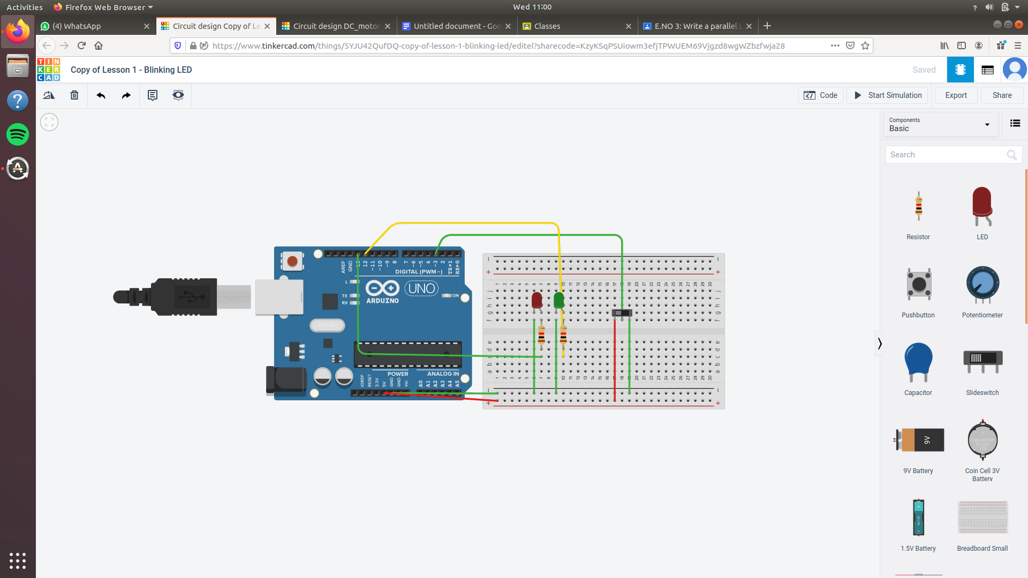

# **E.NO 3: Write a parallel LED blinking program by using slider switch.**

const int switchPin = 3;

const int led1Pin = 12;

const int led2Pin = 13;

void setup()

{

pinMode(switchPin, INPUT);

pinMode(led1Pin, OUTPUT);

pinMode(led2Pin, OUTPUT);

}

void loop() {

int switchVal;

switchVal = digitalRead(switchPin);

if (switchVal == HIGH) {

digitalWrite(led1Pin, HIGH);

delay(500);

digitalWrite(led2Pin, LOW);

delay(500);

}

else {

digitalWrite(led2Pin, HIGH);

delay(500);

digitalWrite(led1Pin, LOW);

delay(500);

}

}

# **E.NO 4: Write a ON/OFF program of DC motor and also display motor current and resistance.**

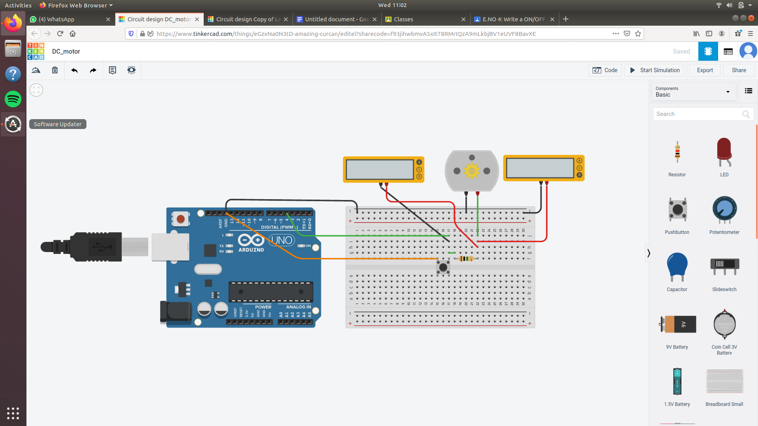

# **E.NO 4: Write a ON/OFF program of DC motor and also display motor current and resistance.**

void setup()

{

pinMode(13, OUTPUT);

}

void loop()

{

digitalWrite(13, HIGH);

delay(1000); // Wait for 1000 millisecond(s)

digitalWrite(13, LOW);

delay(1000); // Wait for 1000 millisecond(s)

}

# **E.NO 5: Write a program to run servo motor with help of resistor and slider switch.**

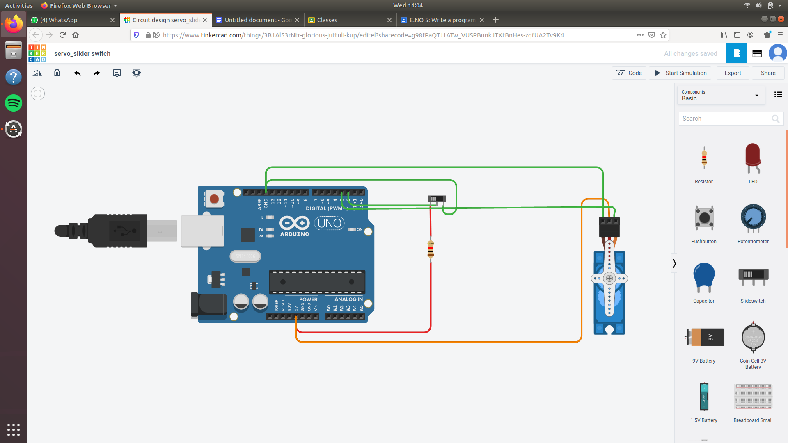

# **E.NO 5: Write a program to run servo motor with help of resistor and slider switch.**

#include<Servo.h>

Servo Myservo;

int pos=0;

void setup()

{

pinMode(2,INPUT);

Myservo.attach(3);

}

void loop()

{

if(digitalRead(2)==LOW){

Myservo.write(90);

}

else

Myservo.write(-180);

}

# **E.NO 6: Write a program of interface LDR sensor with Arduino.**

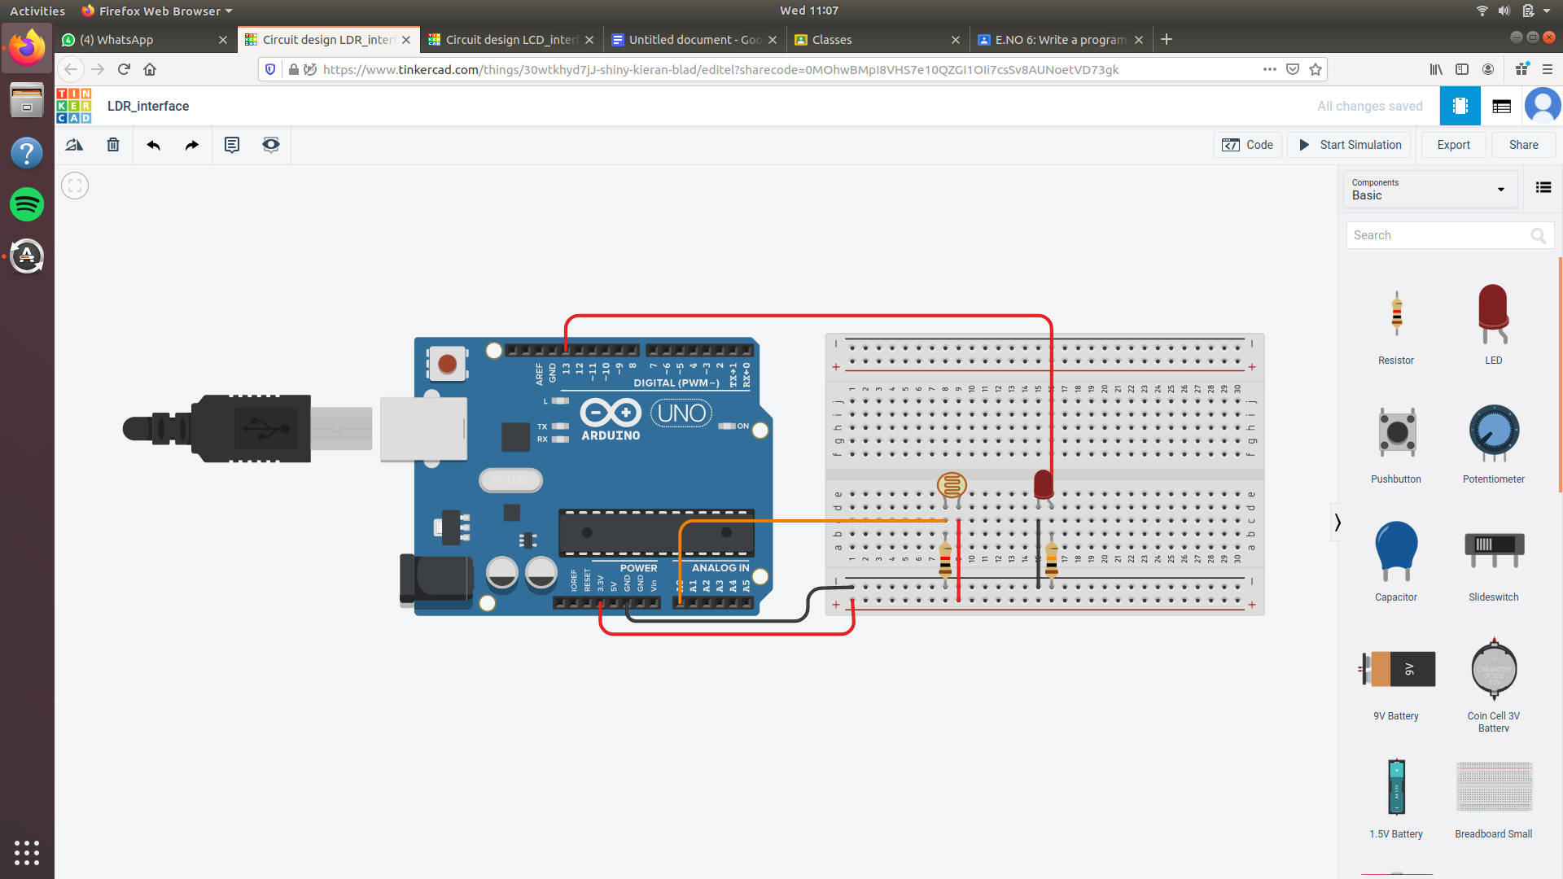

# **E.NO 6: Write a program of interface LDR sensor with Arduino.**

#include<Servo.h>

Servo Myservo;

int pos=0;

void setup()

{

pinMode(2,INPUT);

Myservo.attach(3);

}

void loop()

{

if(digitalRead(2)==LOW){

Myservo.write(90);

}

else

Myservo.write(-180);

}

# **E.NO 7: Write a program of interface photoresistor with Arduino.**

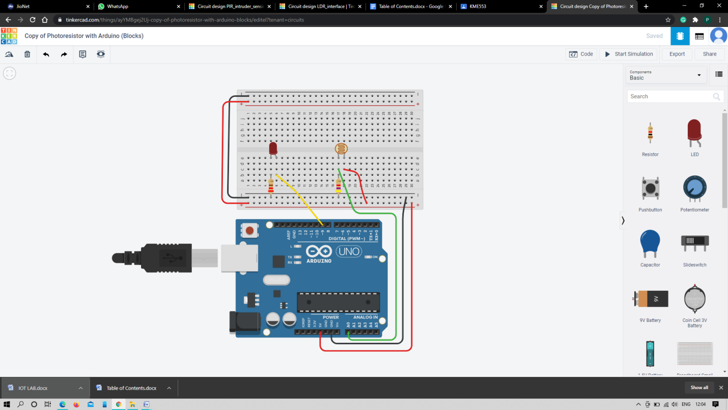

# **E.NO 7: Write a program of interface photoresistor with Arduino.**

int sensorValue = 0;

void setup()

{

pinMode(A0, INPUT);

Serial.begin(9600);

pinMode(9, OUTPUT);

}

void loop()

{

// read the value from the sensor

sensorValue = analogRead(A0);

// print the sensor reading so you know its range

Serial.println(sensorValue);

// map the sensor reading to a range for the LED

analogWrite(9, map(sensorValue, 0, 1023, 0, 255));

delay(100); // Wait for 100 millisecond(s)

}

# **E.NO 8: Write a program to interface LDR sensor and display data on LCD.**

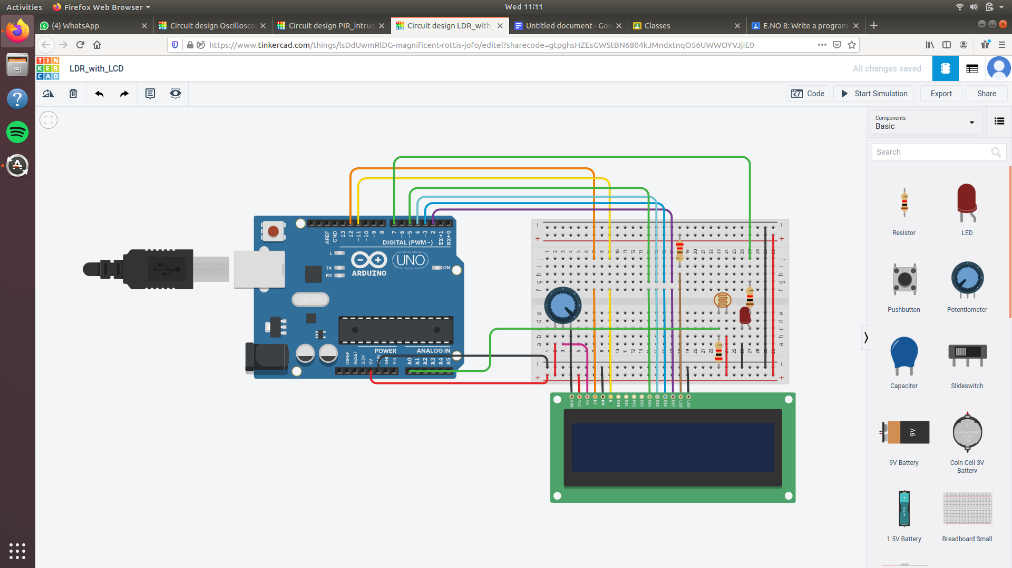

# **E.NO 8: Write a program to interface LDR sensor and display data on LCD.**

#include <LiquidCrystal.h>

LiquidCrystal lcd(12,11,5,4,3,2);

int sensorValue = 0;

int led = 7;

void setu()

{

pinMode(led,OUTPUT);

pinMode(A0,INPUT);

Serial.begin(9600);

lcd.begin(16,2);

lcd.setCursor(0,0);

lcd.print("SmartLightSystem");

}

void loop()

{

lcd.setCursor(0,0);

lcd.print("SmartLightSystem");

sensorValue= analogRead(A0);

Serial.println(sensorValue);

delay(100);

if (sensorValue < 750)

{

lcd.setCursor(0,1);

lcd.print("LED ON");

digitalWrite(led,HIGH);

delay(100);

}

else

{

lcd.setCursor(0,1);

lcd.print("LEDOFF");

digitalWrite(led,LOW);

delay(100);

}

}

# **E.NO 9: Write a program of Intruder sensing.**

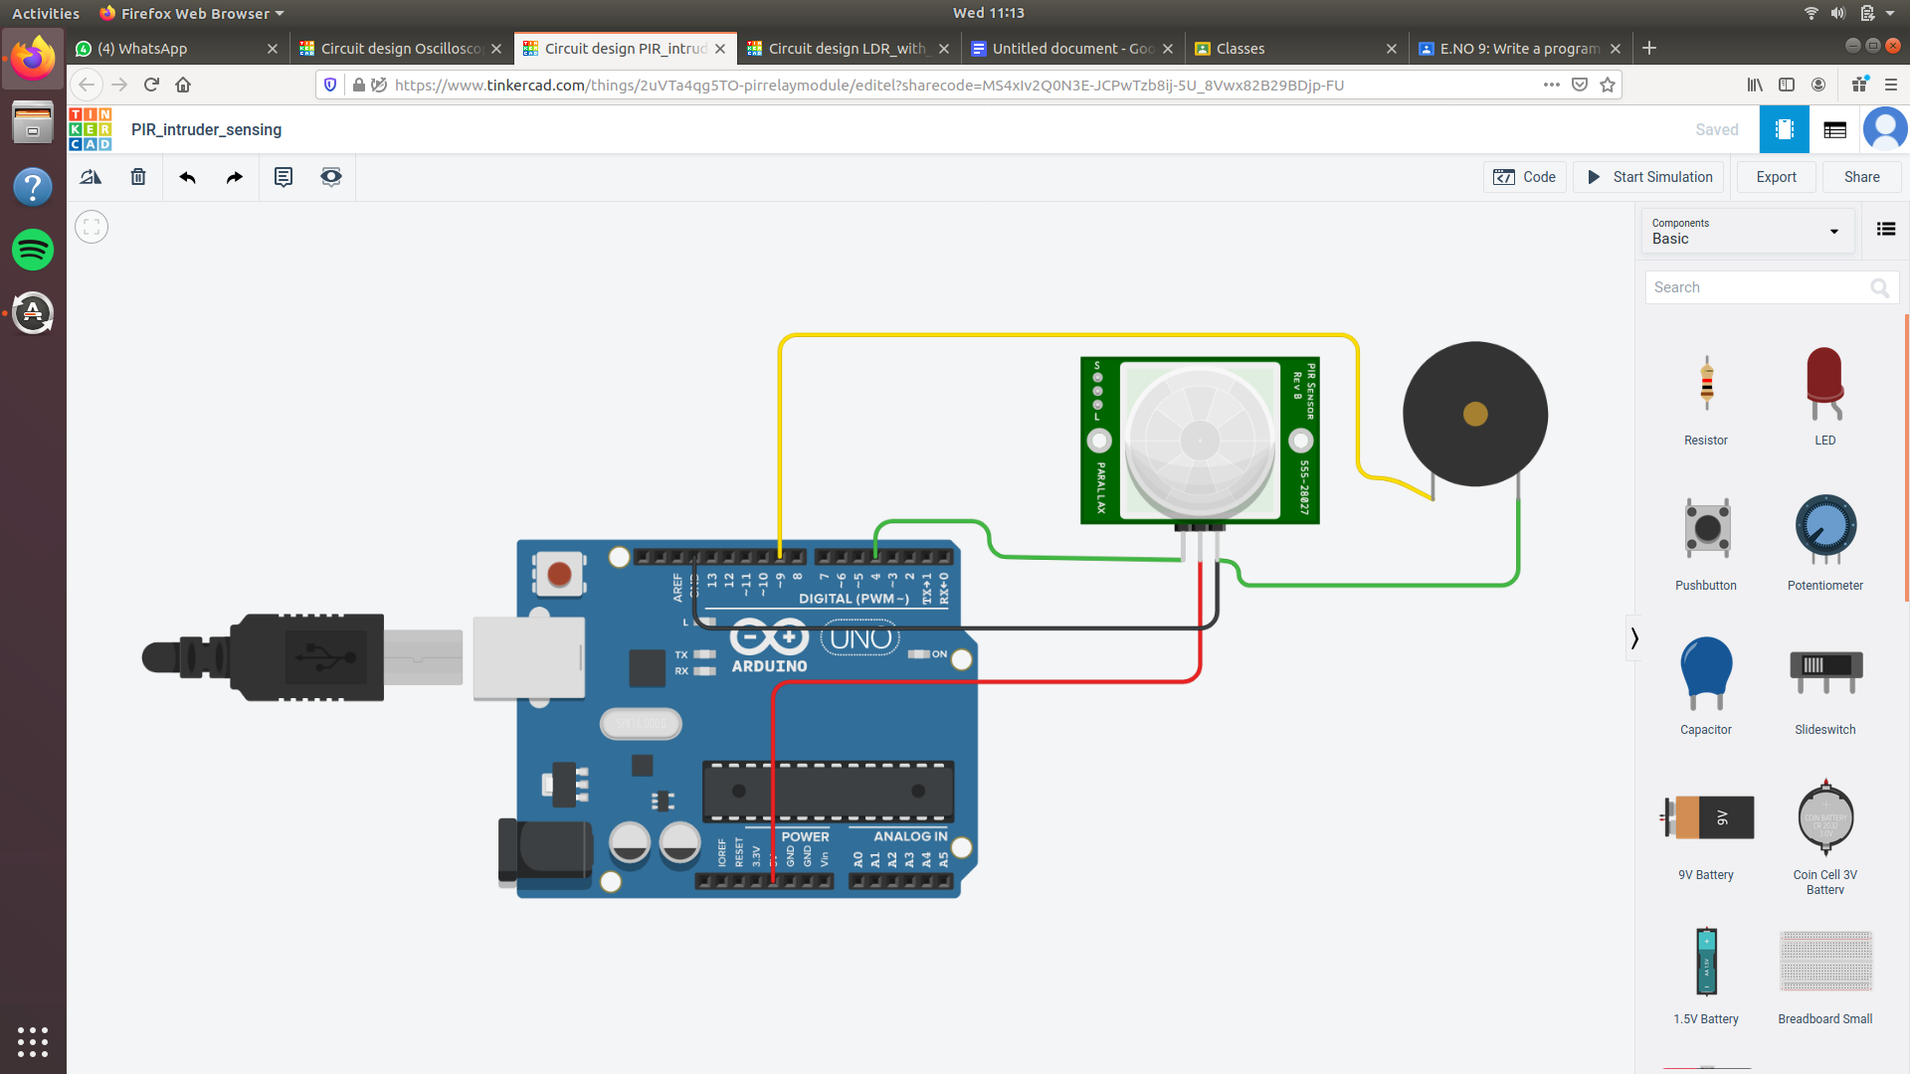

# **E.NO 9: Write a program of Intruder sensing.**

void setup()

{

pinMode(4, INPUT);

pinMode(9, OUTPUT);

Serial.begin(9600);

}

void loop()

{

if (digitalRead(4) == 1) {

tone(9, 523, 1000); // play tone 60 (C5 = 523 Hz)

} else {

noTone(9);

}

Serial.println(digitalRead(4));

delay(10); // Delay a little bit to improve simulation performance

}

# **E.NO 10: Write a program of Duty cycle through Oscilloscope.**

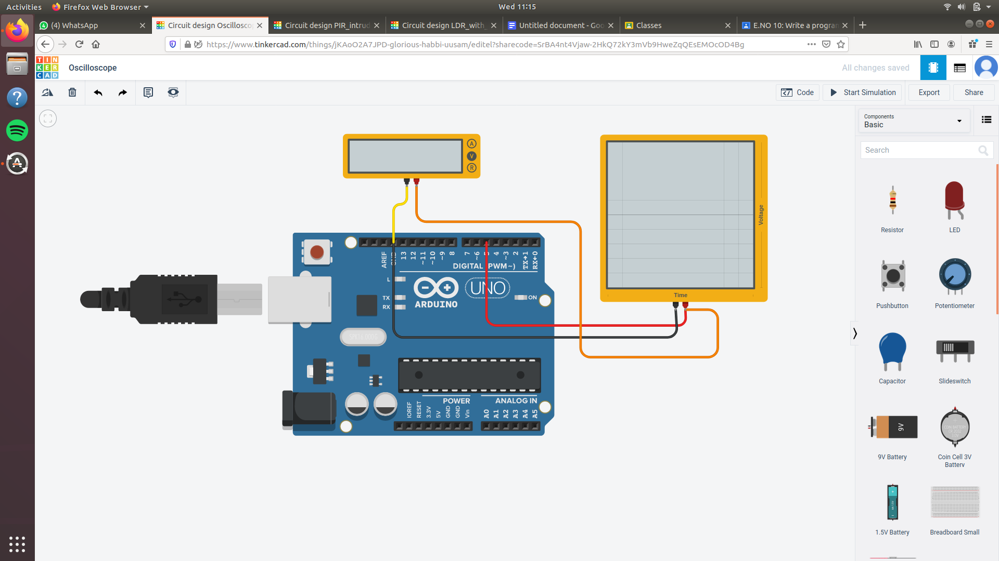

# **E.NO 10: Write a program of Duty cycle through Oscilloscope.**

void setup()

{

pinMode(5, OUTPUT);

}

void loop()

{

analogWrite(5, 200);

delay(10); // Delay a little bit to improve simulation performance

}

# **E.NO 11: Write a program of controlling motor through NPN Resistor.**

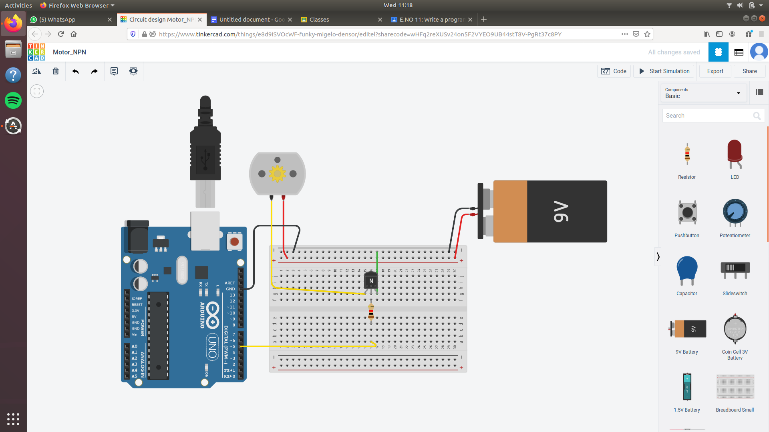

# **E.NO 11: Write a program of controlling motor through NPN Resistor.**

void setup()

{

pinMode(5, OUTPUT);

}

void loop()

{

analogWrite(5, 255);

delay(1000); // Wait for 1000 millisecond(s)

analogWrite(5, 200);

delay(2000); // Wait for 2000 millisecond(s)

analogWrite(5, 100);

delay(2000); // Wait for 2000 millisecond(s)

analogWrite(5, 255);

delay(2000); // Wait for 2000 millisecond(s)

analogWrite(5, 0);

delay(2000); // Wait for 2000 millisecond(s)

}

# **E.NO 12: Write a Program of Run motor forward/Reverse motion by using H-Bridge motor driver circuit.**

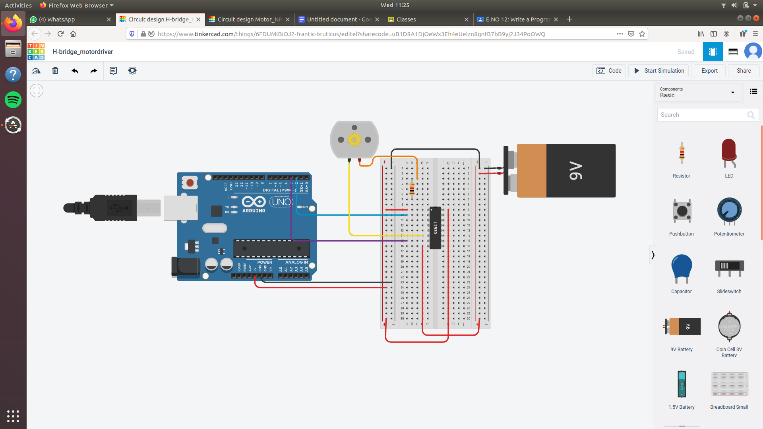

# 

# **E.NO 12: Write a Program of Run motor forward/Reverse motion by using H-Bridge motor driver circuit.**

void setup()

{

pinMode(2, OUTPUT);

pinMode(3, OUTPUT);

}

void loop()

{

digitalWrite(2, HIGH);

digitalWrite(3, LOW);

delay(1000); // Wait for 1000 millisecond(s)

digitalWrite(2, LOW);

digitalWrite(3, HIGH);

delay(1000); // Wait for 1000 millisecond(s)

digitalWrite(2, HIGH);

digitalWrite(3, HIGH);

delay(1000); // Wait for 1000 millisecond(s)

}

# **E.NO 13: Write a Program to sense data from ultrasonic sensor and run two geared motor.**

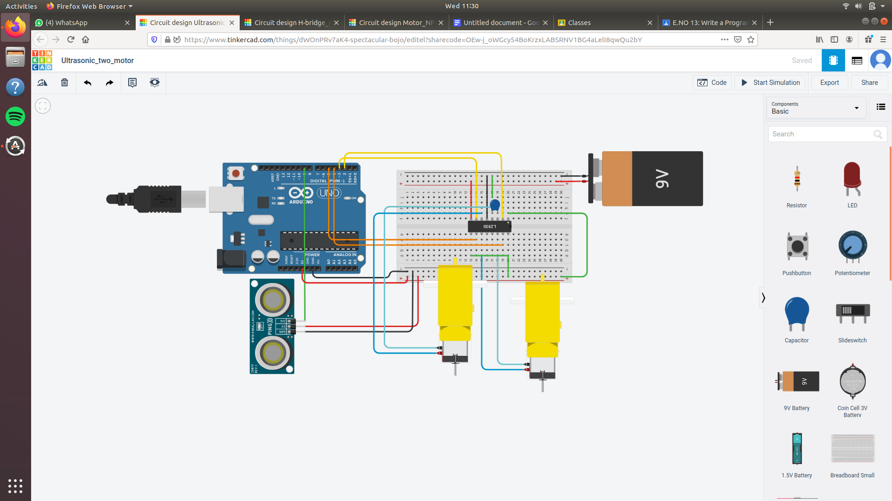

# **E.NO 13: Write a Program to sense data from ultrasonic sensor and run two geared motor.**

long readUltrasonicDistance(int triggerPin, int echoPin)

{

pinMode(triggerPin, OUTPUT); // Clear the trigger

digitalWrite(triggerPin, LOW);

delayMicroseconds(2);

// Sets the trigger pin to HIGH state for 10 microseconds

digitalWrite(triggerPin, HIGH);

delayMicroseconds(10);

digitalWrite(triggerPin, LOW);

pinMode(echoPin, INPUT);

// Reads the echo pin, and returns the sound wave travel time in microseconds

return pulseIn(echoPin, HIGH);

}

void setup()

{

pinMode(2, OUTPUT);

pinMode(3, OUTPUT);

pinMode(4, OUTPUT);

pinMode(5, OUTPUT);

}

void loop()

{

if (0.01723 * readUltrasonicDistance(9, 9) >= 150) {

digitalWrite(2, LOW);

digitalWrite(3, HIGH);

digitalWrite(4, HIGH);

digitalWrite(5, LOW);

} else {

digitalWrite(2, LOW);

}

delay(10); // Delay a little bit to improve simulation performance

}

# **E.NO 14: Write a program of sense data from ultrasonic sensor and run servomotor.**

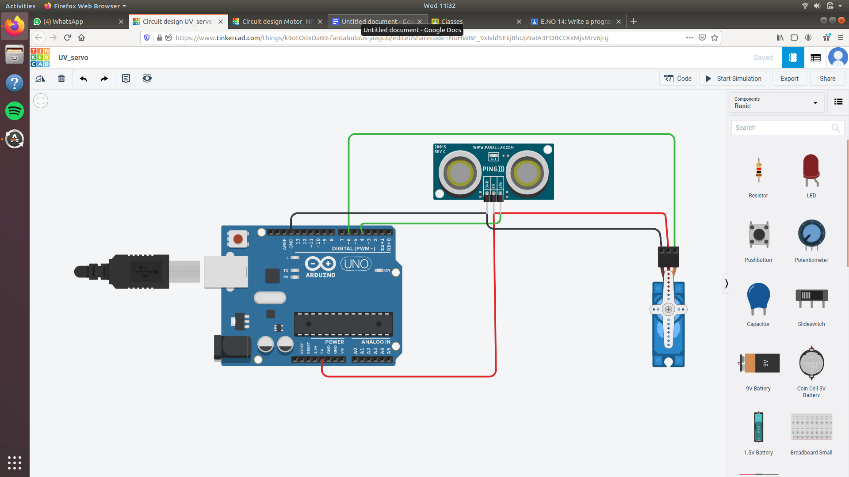

# **E.NO 14: Write a program of sense data from ultrasonic sensor and run servomotor.**

#include <Servo.h>

Servo servo_6;

long readUltrasonicDistance(int triggerPin, int echoPin)

{

pinMode(triggerPin, OUTPUT); // Clear the trigger

digitalWrite(triggerPin, LOW);

delayMicroseconds(2);

// Sets the trigger pin to HIGH state for 10 microseconds

digitalWrite(triggerPin, HIGH);

delayMicroseconds(10);

digitalWrite(triggerPin, LOW);

pinMode(echoPin, INPUT);

// Reads the echo pin, and returns the sound wave travel time in microseconds

return pulseIn(echoPin, HIGH);

}

void setup()

{

servo_6.attach(6, 500, 2500);

Serial.begin(9600);

}

void loop()

{

servo_6.write(0);

delay(1000); // Wait for 1000 millisecond(s)

servo_6.write(10);

delay(2000); // Wait for 2000 millisecond(s)

servo_6.write(20);

delay(1000); // Wait for 1000 millisecond(s)

servo_6.write(30);

delay(1000); // Wait for 1000 millisecond(s)

servo_6.write(90);

delay(1000); // Wait for 1000 millisecond(s)

Serial.println(0.01723 * readUltrasonicDistance(4, 4));

}

# **E.NO 15: Write a program to run any output device with help of relay module.**

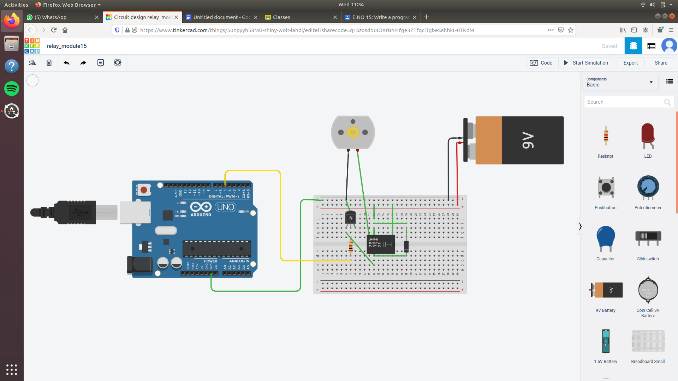

# **E.NO 15: Write a program to run any output device with help of relay module.**

void setup()

{

pinMode(5, OUTPUT);

}

void loop()

{

digitalWrite(5, HIGH);

delay(2000); // Wait for 2000 millisecond(s)

digitalWrite(5, LOW);

delay(2000); // Wait for 2000 millisecond(s)

}

# **E.NO 16: Write a program to sense data from PIR sensor and RUN any Electrical devices through relay module.**

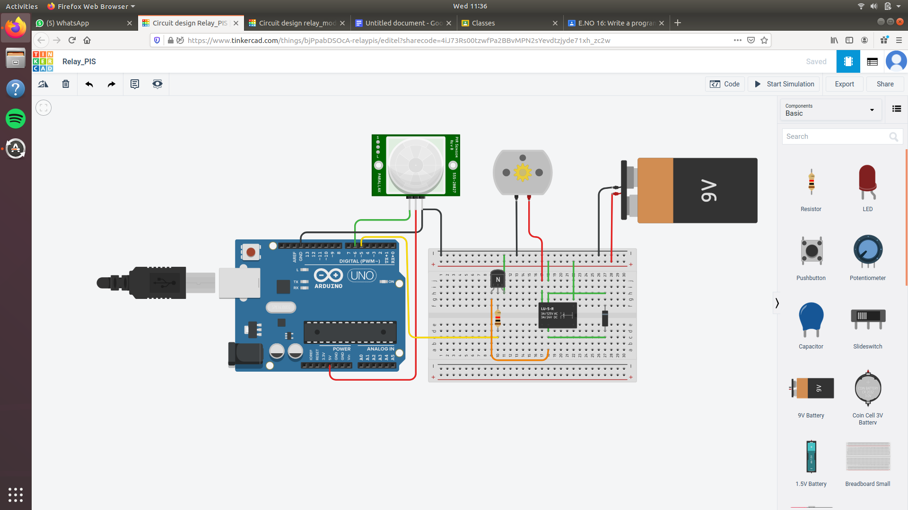

# **E.NO 16: Write a program to sense data from PIR sensor and RUN any Electrical devices through relay module.**

void setup()

{

pinMode(6, INPUT);

pinMode(5, OUTPUT);

}

void loop()

{

if (digitalRead(6) == 1) {

digitalWrite(5, HIGH);

delay(1000); // Wait for 1000 millisecond(s)

} else {

digitalWrite(5, LOW);

delay(1000); // Wait for 1000 millisecond(s)

}

}